# Browsing the Store Front – Placing Orders

### Product pages

The OpenCart default product page will follow the structural format seen below.

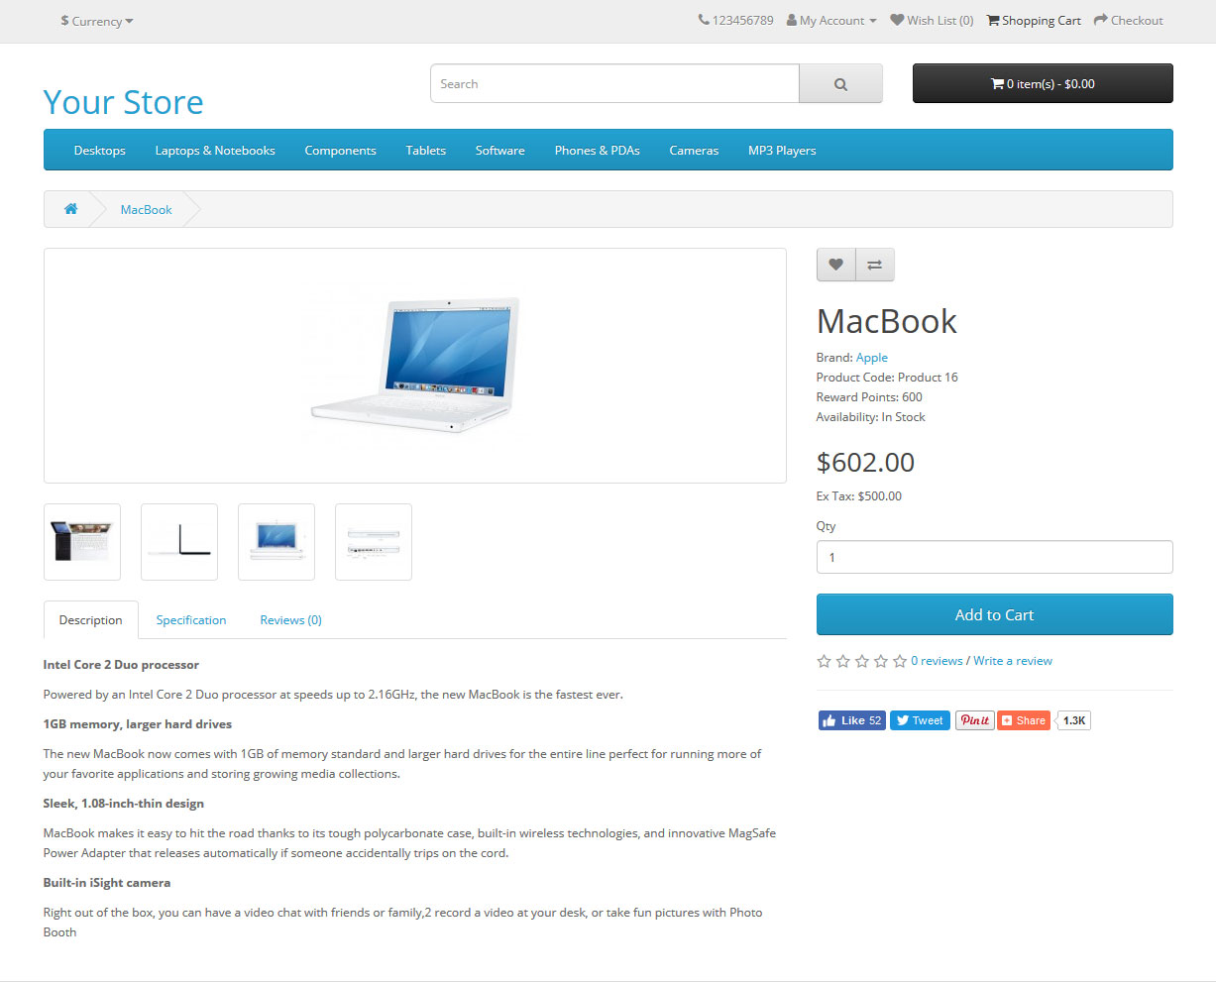

From here, the customer can select a quantity and add the product to their cart, pushing the “Add to cart” blue button.

The field for quantity “Qty” is a mandatory field and must permit only integer numbers below zero. Otherwise, an error message is displayed.

There are some products that may require other additional information to be added to the cart and these are mandatory fields, as shown below:

* Delivery date: date type, yyyy-mm-dd format. This field contains a data by default;
* Available options: dropdown color list.

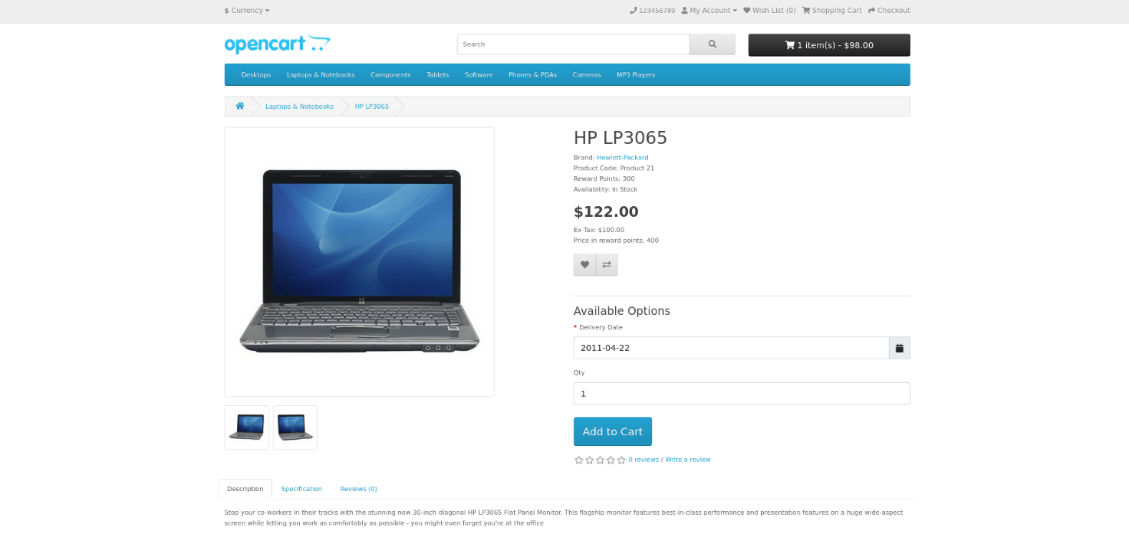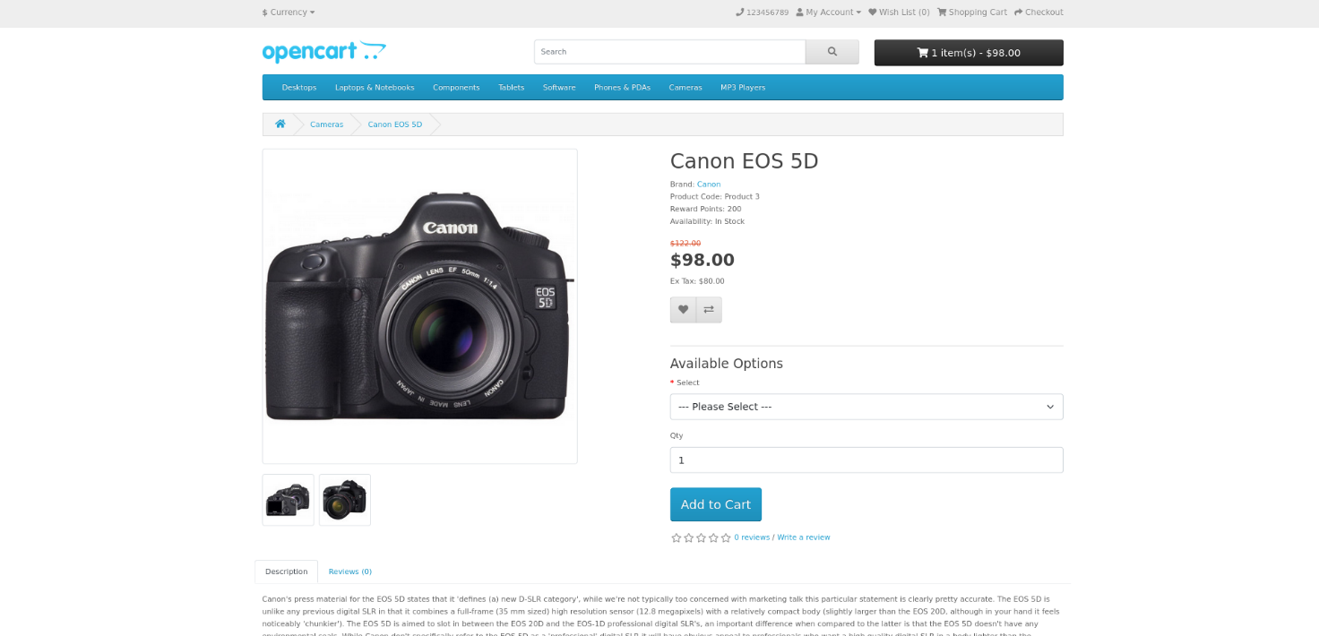

When a customer tries to add to cart a product without specifying the available option, they receive an error message just below the field.

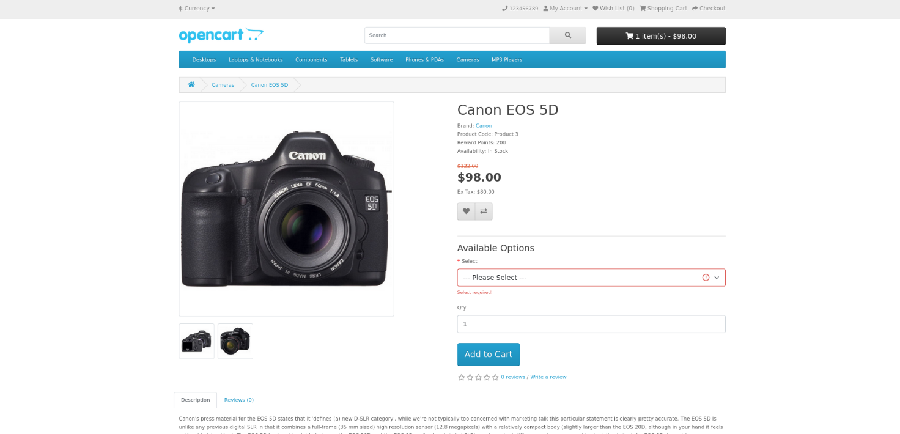

### Shopping Cart page

Once a customer adds a product to the cart, they receive a confirmation message (a green message as below) and they can access the shopping cart in the header, by pressing "Shopping Cart" button or using the black button from the right side of the search field (this button can be hovered) and then pressing the “View cart” button.

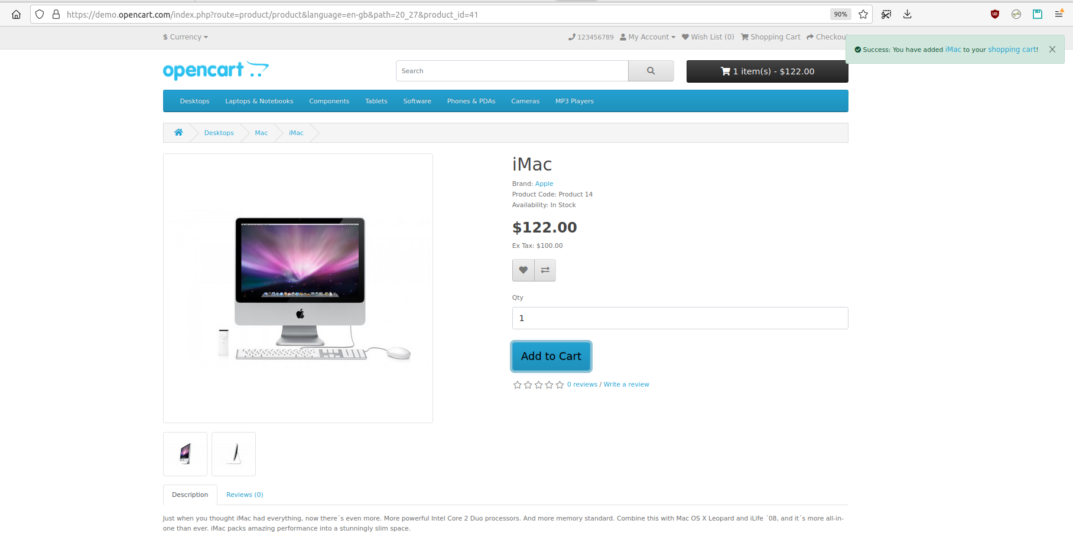

The shopping cart gives an overview of the product selected by including the categories "Image", "Product Name", "Model", "Quantity", "Unit Price", and "Total".

The quantity of a product can be refreshed form the blue button next to numeric field “Quantity” (“Update” button). A green message is displayed in the right upper corner, after the refresh. If the value enterd is “0”, the product will be deleted.

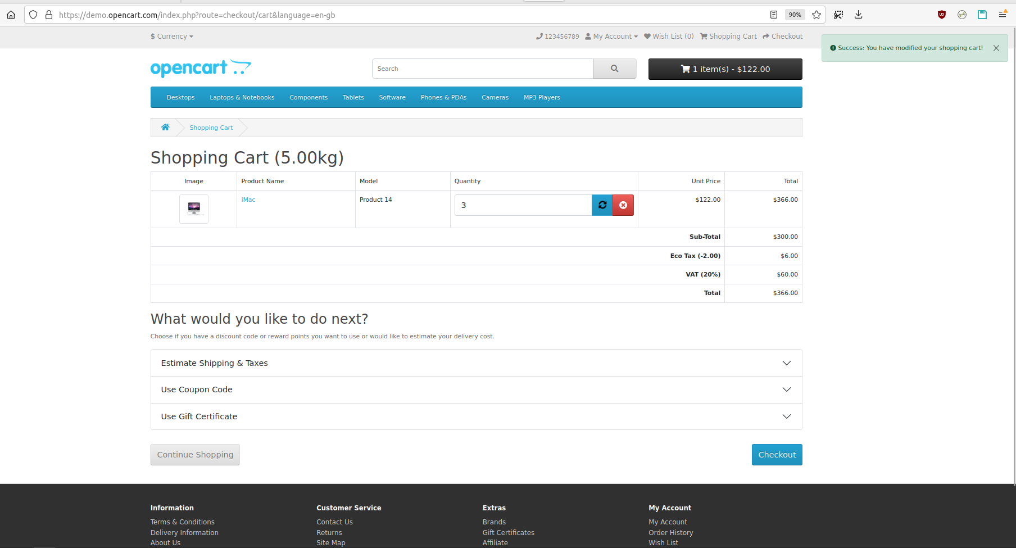

Also, the product can be deleted from cart using the red button next to numeric field “Quantity” (“Remove” button). A green message is displayed in the right upper corner, after the delete action.

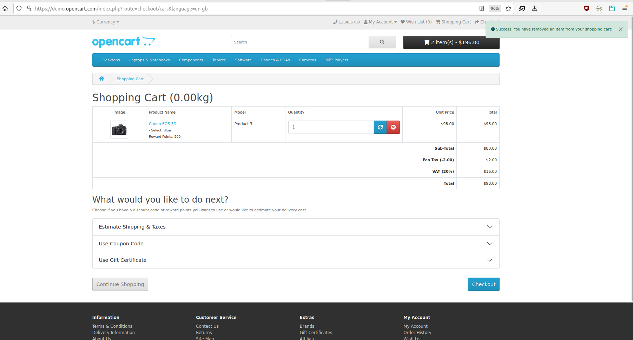

The customer has an option to add a coupon code or gift voucher, or estimate shipping & taxes, before heading to the checkout. (not in scope)

After this options, a table with information about the price without Eco Tax (2$ per product) and VAT (20%), and the final price (Total) is displayed.

The "Continue Shopping" button links back to the homepage.

The button “Checkout” opens the next page, from which the order is placed.

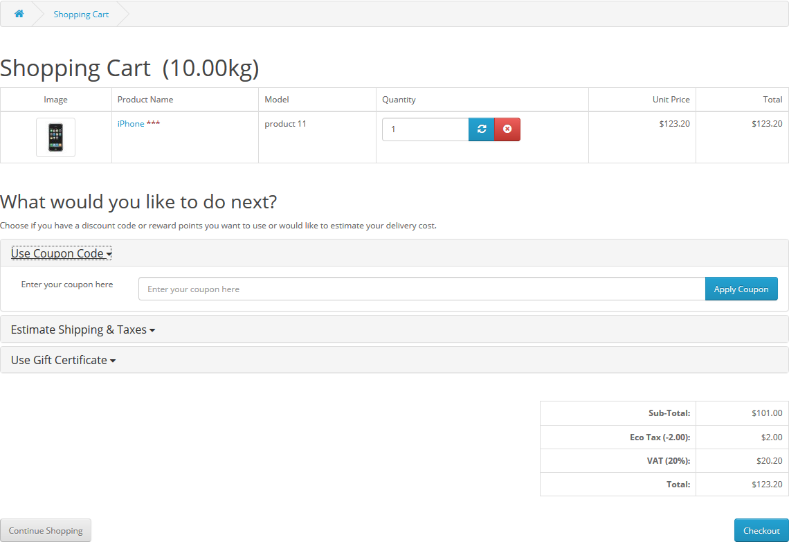

### Checkout

Once a product has been added to the cart, the customer can continue to the checkout to make their product purchase. The Checkout page can be accessed using 3 different methods:

* the “Checkout” blue button at the button of the Shopping Cart page
* from the “Checkout” grey button on the right side of the header
* using the black button from the right side of the search field (this button can be hovered) and then pressing the “Checkout” button.

Customer checkout using OpenCart is a simple process that can be completed in 5 steps.

Step 1: Checkout options

The customer can log into (as explained in the Login section) or register their account, or select guest checkout, using the proper radio button. When using a guest account, setting a password and acceptance of the Privacy Policy are no longer required.

Step 2: Payment and Shipping Address

Personal details including "First Name", "Last Name", and "E-mail" are filled into a form and are mandatory fields. "First Name" and "Last Name" must have between 1 and 32 characters, and "E-mail" has to provide a valid e-mail address.

It also requires the customer's address details, as Payment Address, which contain as mandatory fields “Address 1”, “City”, “Post Code”, “Country”, and “Region/State”. The other fields, “Company” and “Address 2”, are optional. “Address 1” must have between 3 and 128 characters and “City” must have between 2 and 128 characters. “Postcode” must have between 2 and 10 characters. In “Country” and “Region/State” fields, the customer must choose from a drop-down list. “Company” and “Address 2” does not have any constraints.

The user can check a box to indicate that the delivery details and billing details are the same (this check box is by default checked when they landed on Checkbox page). This will cause it to skip over this step to Delivery Method. If the delivery details are different from the billing details, the customer can enter this information in a form similar with the one above.

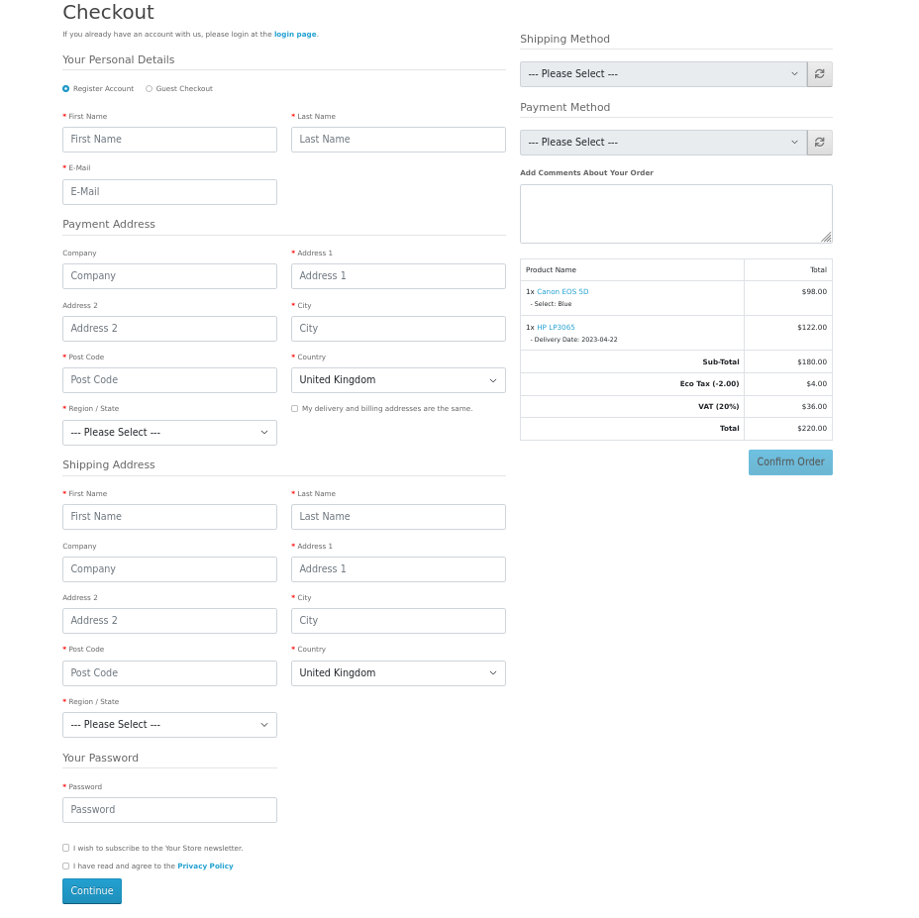

A password between 4 and 20 characters must be enter in “Password” field.

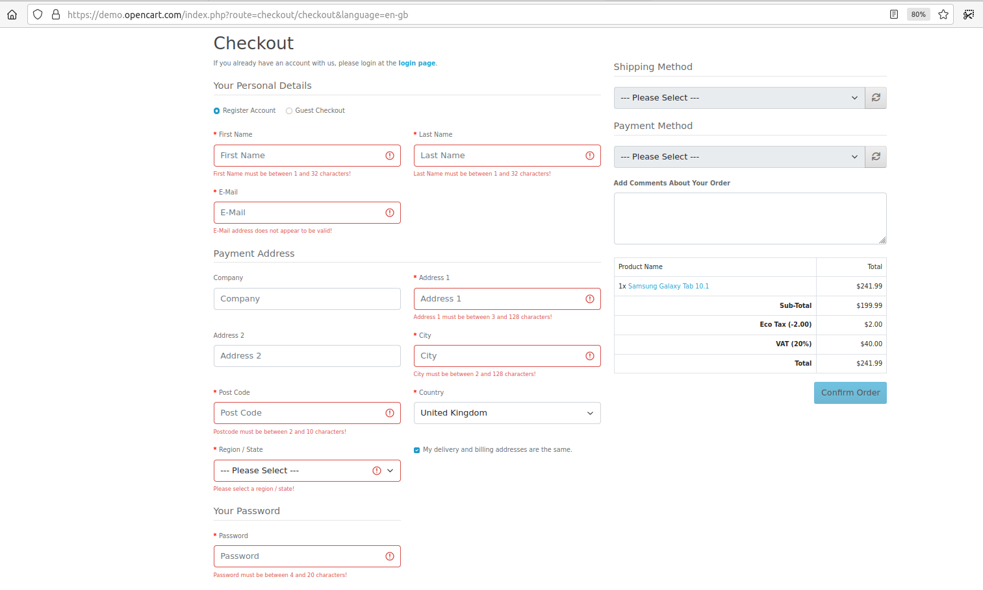When an invalid data is entered in this form, there is an error message that is displayed below the field, as in the next pictures:

In addition, the last step here is to check if the customer want to receive newsletters.

Also, The Privacy Policy checkbox must be check in order to continue. Otherwise, a pink message is displayed in the upper right corner, as below:

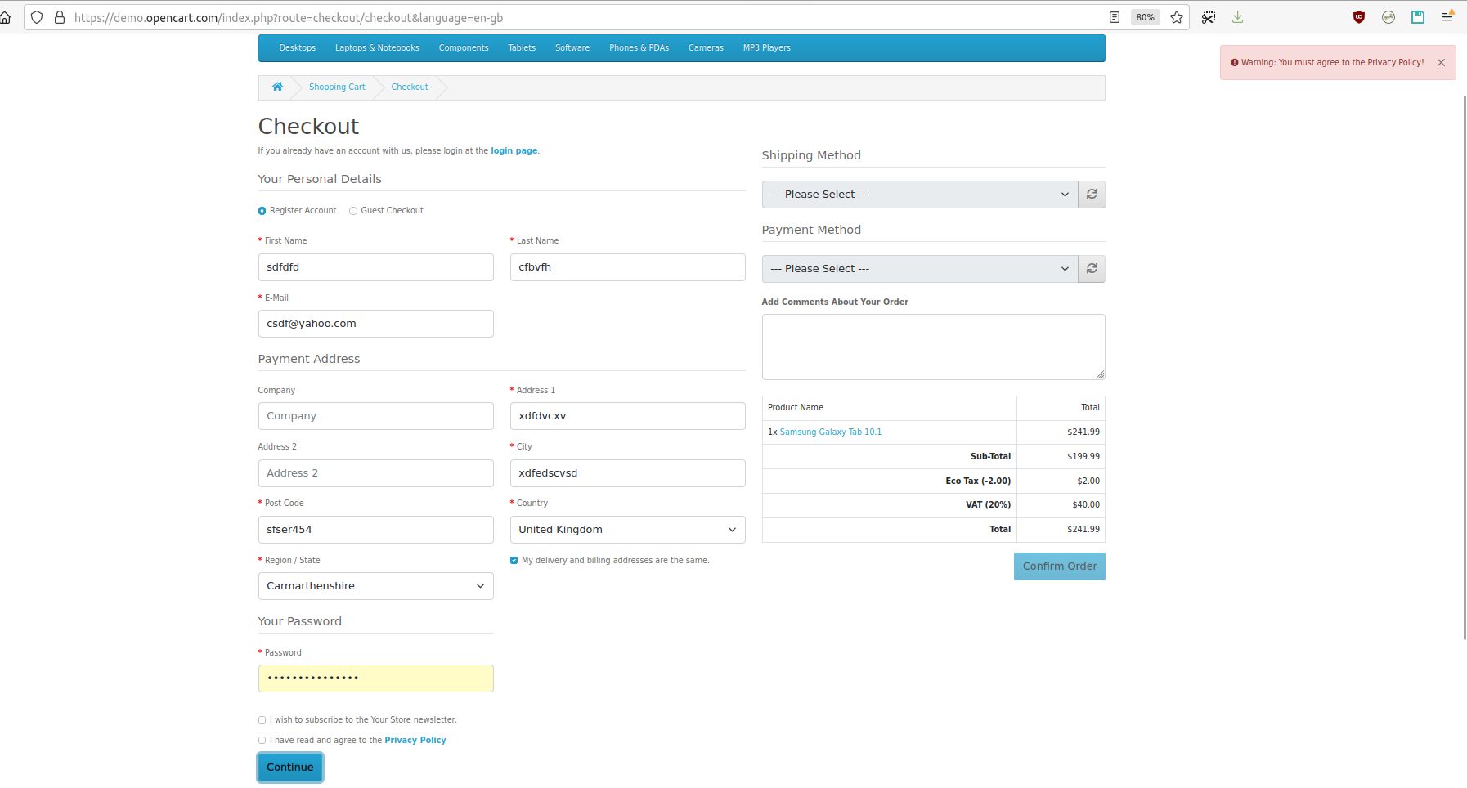

Then, by pressing the “Continue” button, the account is saved and a green message appears in the upper right corner, as below:

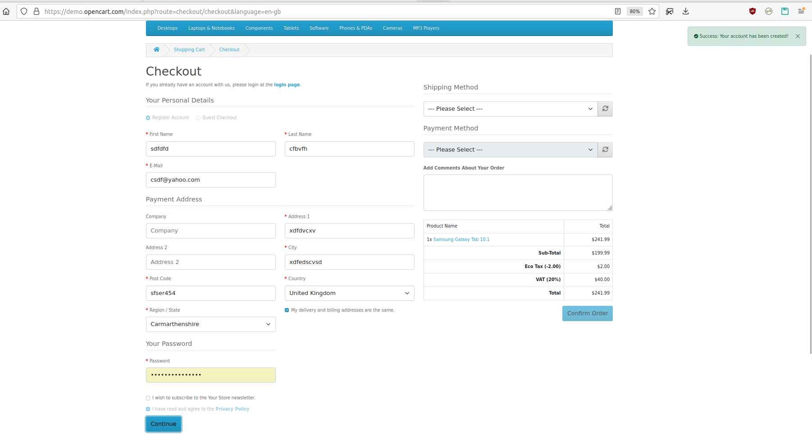

Step 3: Shipping method

A method of shipping is selected here, form a dropdown list. A message is displayed after the choice is made.

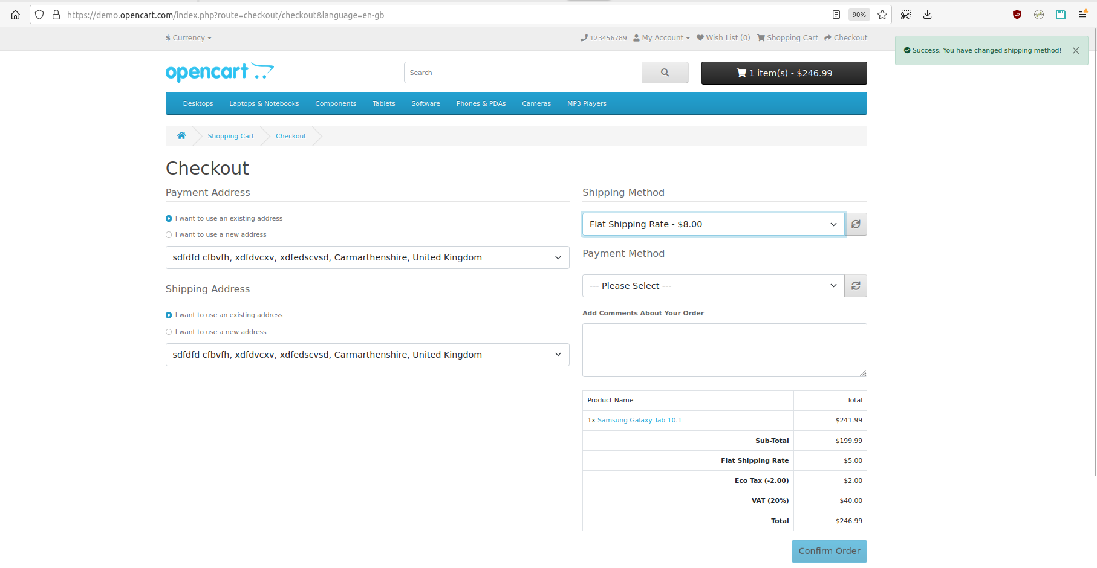

If the customer does not select a value from the dropdown list, a pink message is displayed in the upper right corner, as below:

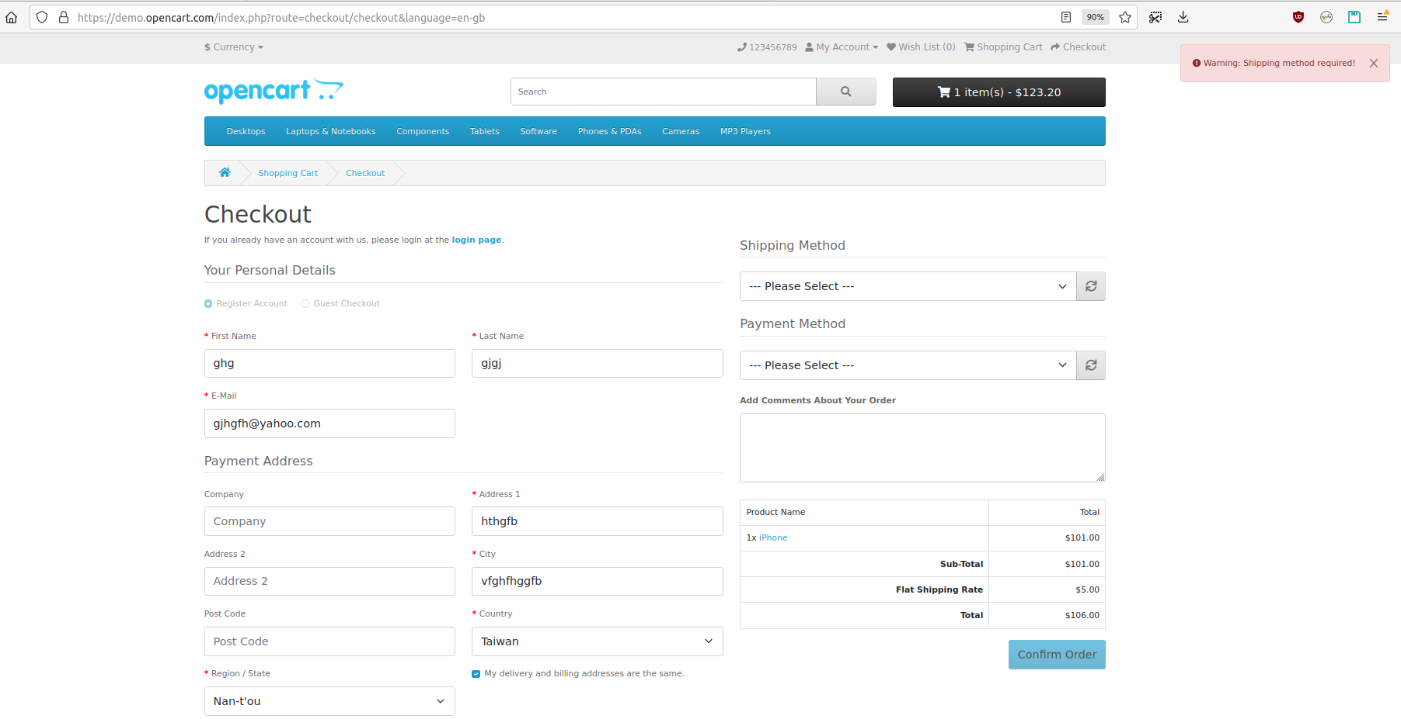

Step 4: Payment method

The customer selects their method of payment here, form a dropdown list and may add comments about their order in the comment box. A message is displayed after the choice is made.

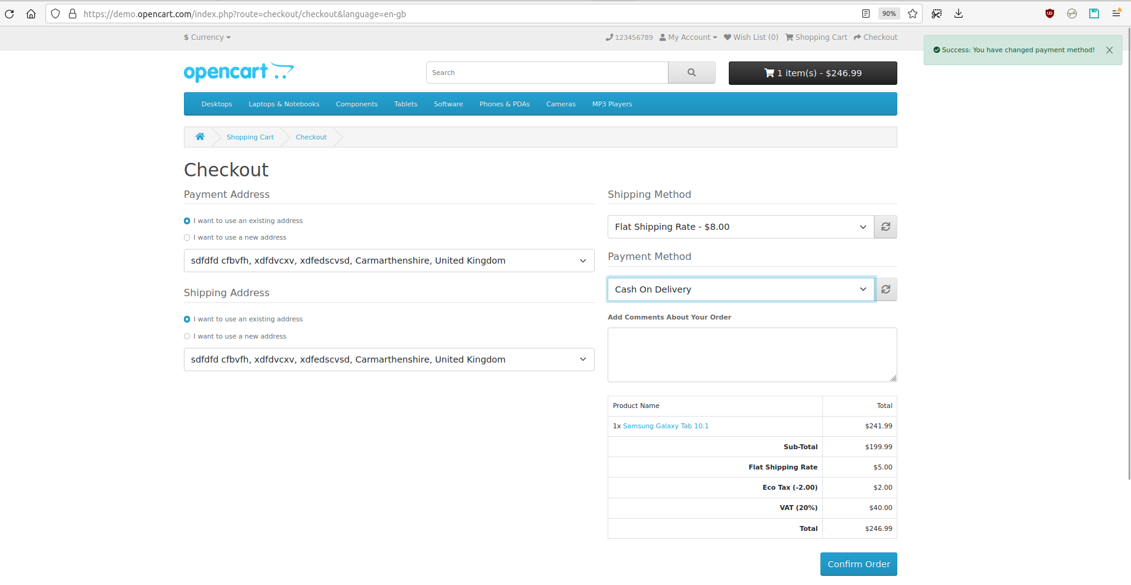

If the customer does not select a value from the dropdown list, a pink message is displayed in the upper right corner, as below:

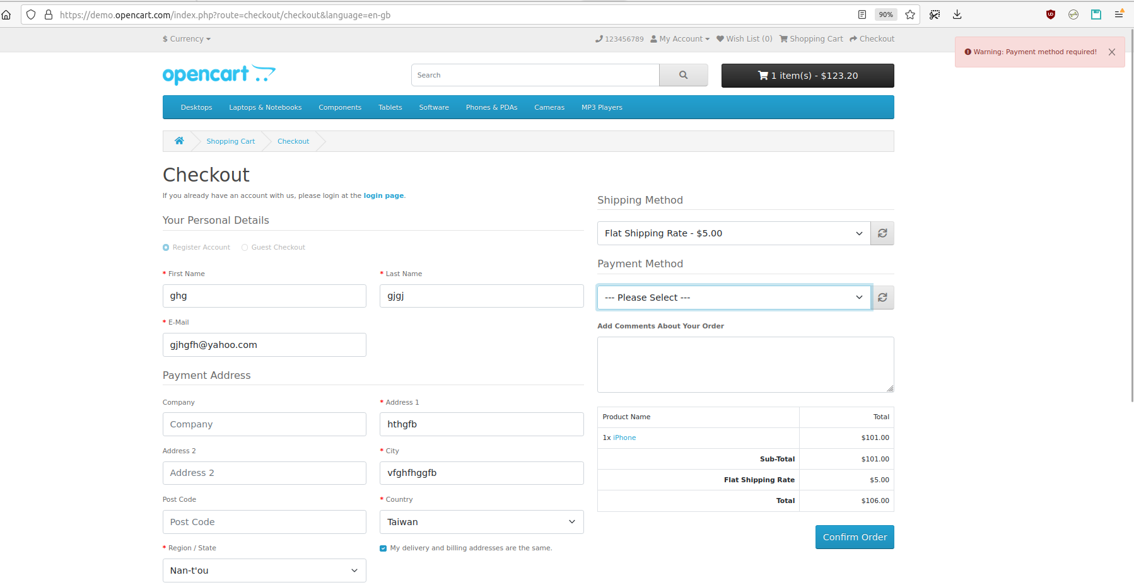

Step 5: Confirm order

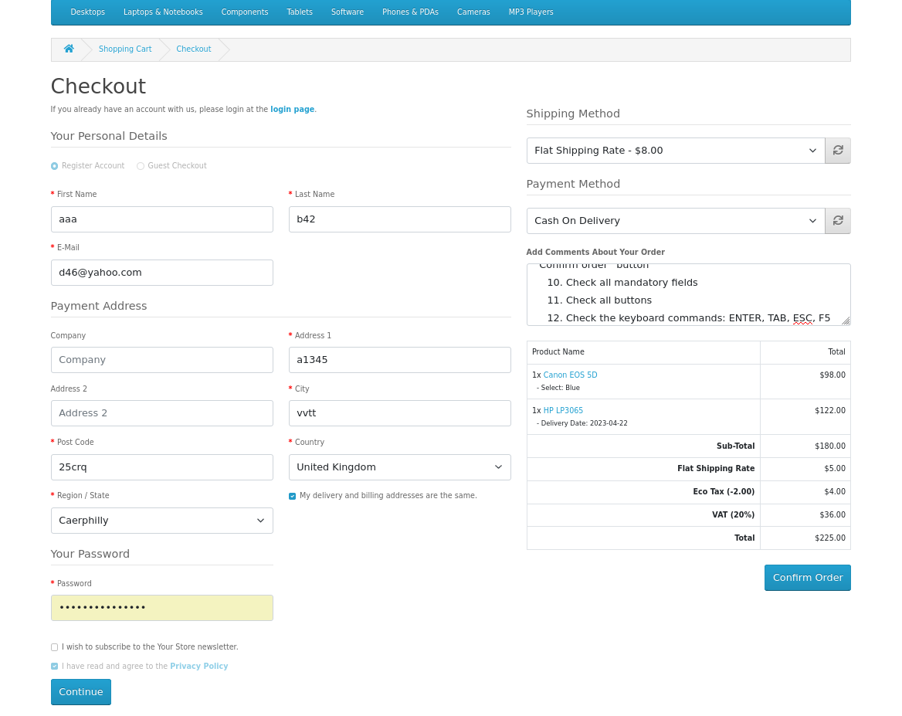In this last step, the customer will see an overview of their purchase, including the product description, quantity, and price (with tax & shipping).

After pressing the “Confirm order” blue button at the bottom of the page, a new page is open to confirm that the order was successfully placed. By clicking on the “Continue” blue button, the customer lands on the homepage.

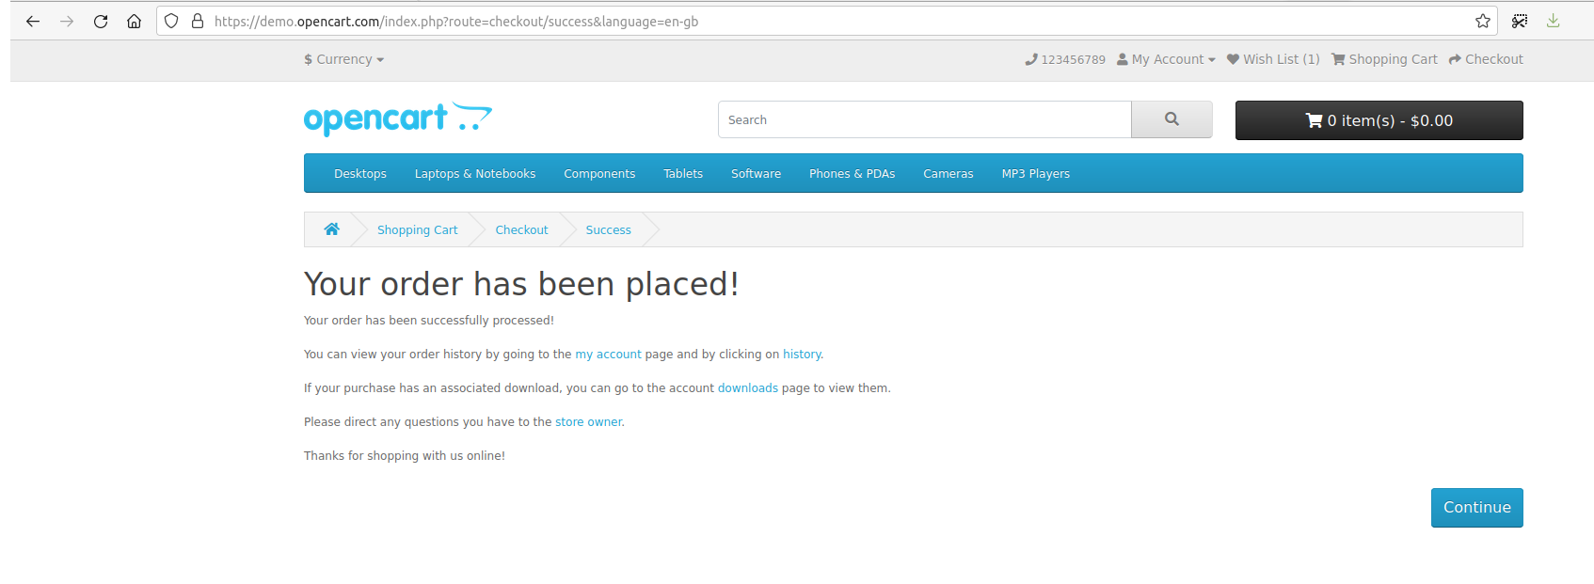

Anytime when in a page, a customer can use the TAB key to navigate through the buttons and fields. When on the selected tab, the ENTER key is pressed, that field became available for editing, or the button is executed.

When the customer wants to cancel the data entered in the account fields, prior to saving, the F5 key will permit this. After the account is saved, pressing the F5 key has no effect at all.

The ESC key does not have any effect when it is pressed anywhere in the store pages.

Aproved by:

Nicolici Venera, reviewer